**KBS Deliverable-3**

**Visualization Charts**

**Group-5**

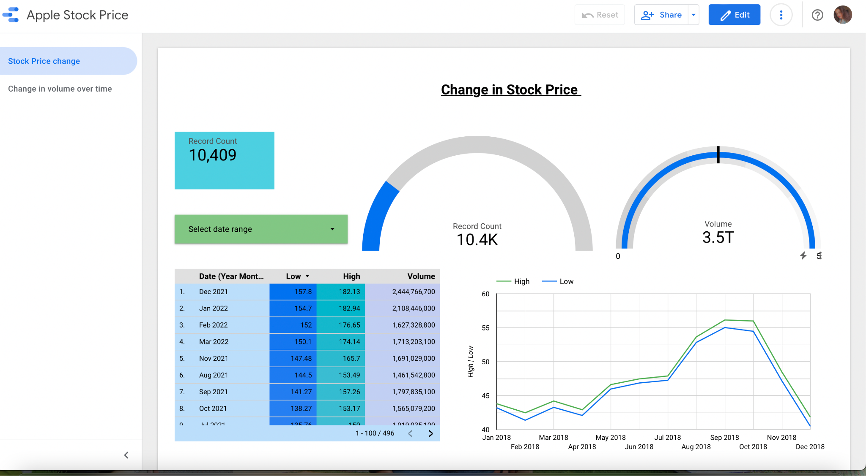

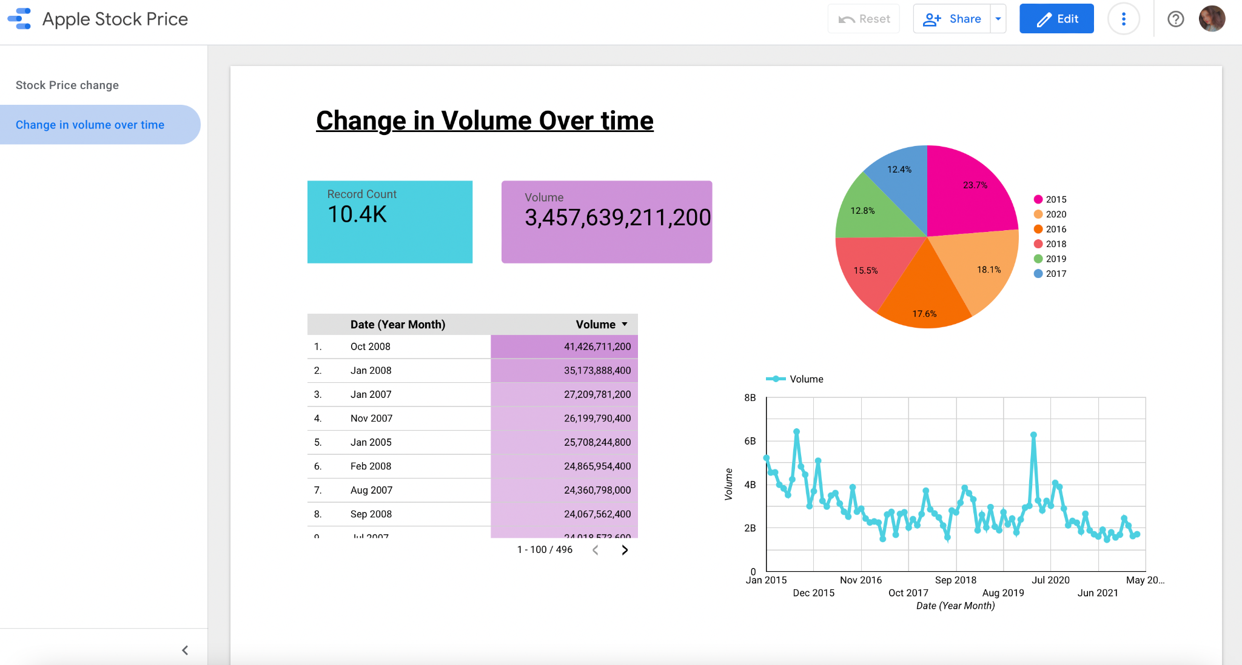

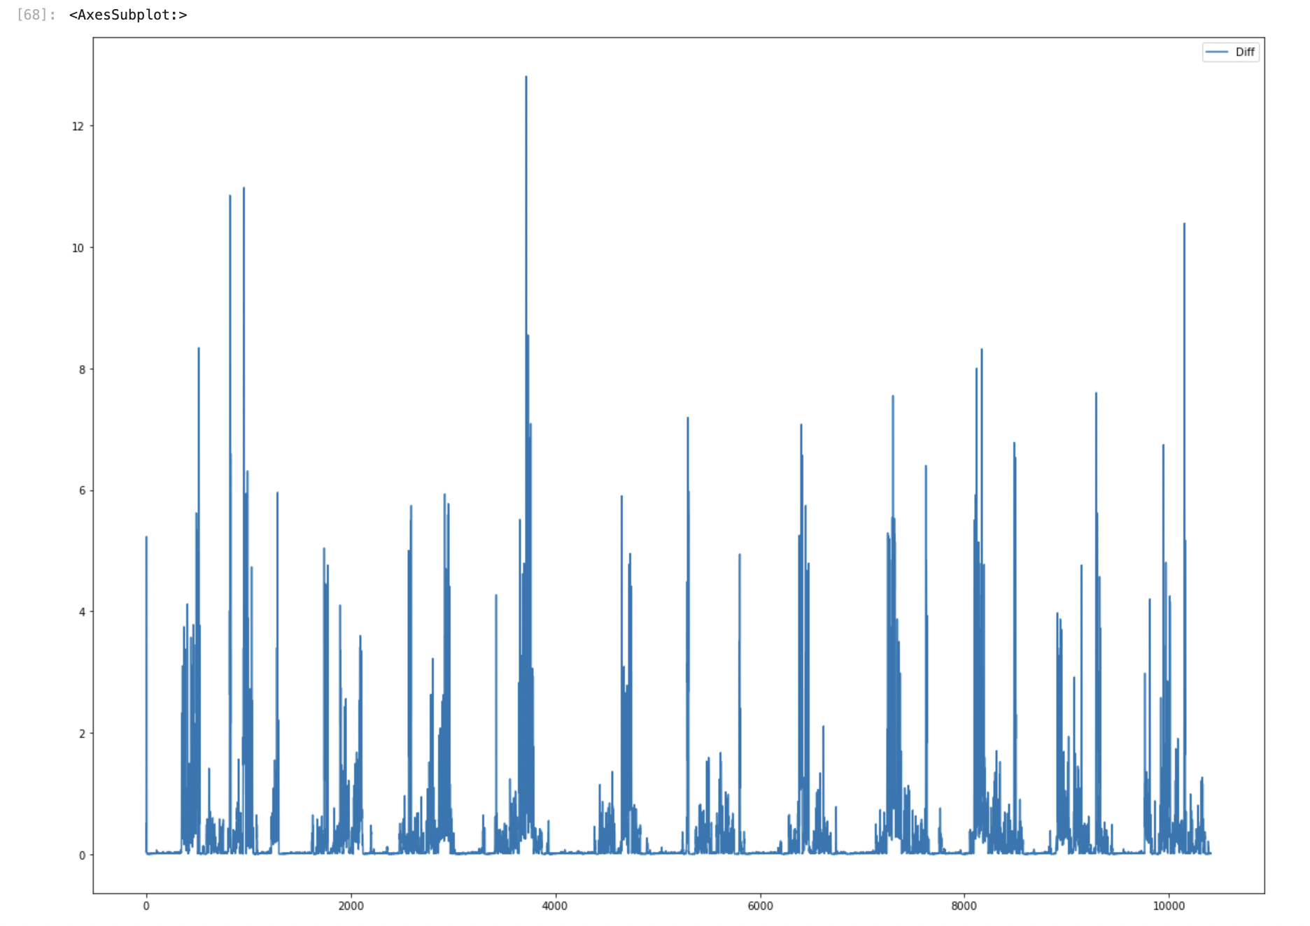

Chart: Forecast future stock performance?

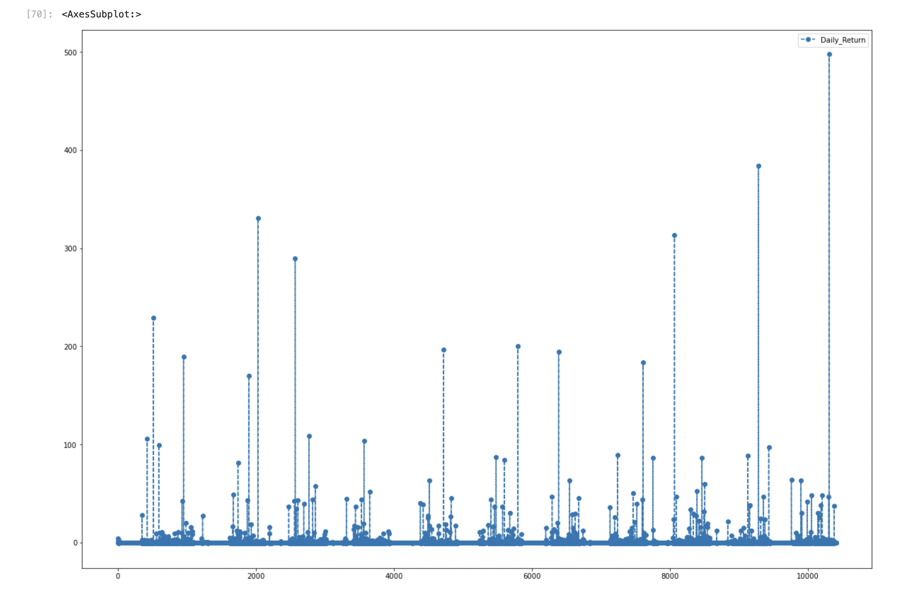

Chart: Average daily return of stock